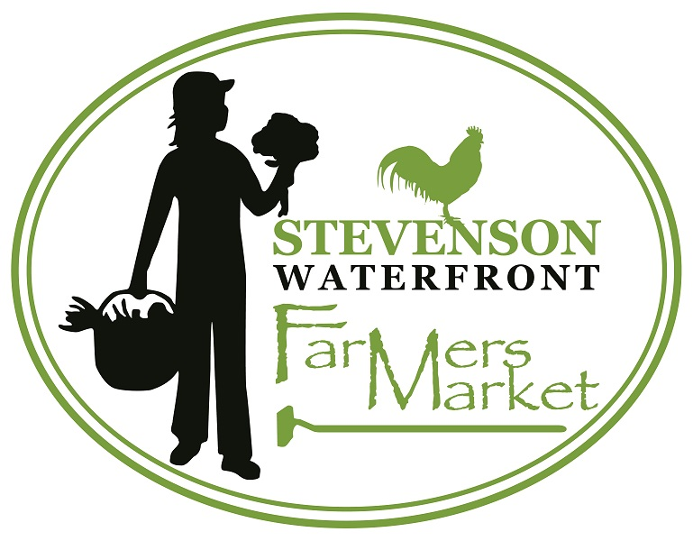 2022 Vendor Application
Every Saturday 10-2pm June 11th – Oct 8th
(Vendors arrive at 9:10am)
WATERFRONT LOCATION 140 SW Cascade Ave
Annual Membership Fee: $40 payable with completed application
Booth Fee $15 Each Week
Double Space Fee 20 ft x 10 ft : $30 Each Week
~ or for Permanente Space Assigned..
Full Season Fee: $280 (includes the Membership fee and 2 free weeks) $520 for double space
Produce Vendors who pay for a full season upfront and attend the entire season with no more than two abscesses will be eligible for a 50% refund on the last market day.
Make checks to Stevenson Farmers Market & mail to Stevenson Farmers’ Market,
P.O. Box 1222 Stevenson, WA 98648
Farmers.Market.Stevenson@gmail.com
Market Manager Pharaoh Skinner’s Market Phone 509)427-4707 ( to use market day) Cell: 360-762-9191
StevensonFarmersMarket.com
Please Keep for your records.

Stevenson Farmers’ Market Association- Market Guidelines 2022 Statement of Purpose
To give growers and producers of Washington agricultural commodities and other farm-related products or crafts alternative marketing opportunities;
To promote the sale of Washington/Oregon-grown farm and craft products;
To improve the variety, freshness, taste and nutritional value of produce available in the Skamania County area;
To provide an opportunity for farmers and people from rural communities to deal directly with each other, rather than through third parties, and to thereby get to know and learn from one another;
To provide an educational forum for consumers to learn the uses and benefits of quality, locally grown or prepared food products;
To provide educational opportunities for producers to test and refine their products and marketing skills; and;
To enhance the quality of life in the Greater Skamania County area by providing a community activity which fosters social gathering and interaction.

MARKET SEASON: The 2022 season will start June 11 and end Oct 8.
MARKET HOURS: Vendors must arrive between 9 and 915am.
The market will be open to the public on Saturdays, from 10 a.m. until 2:00 p.m
MARKET LOCATION: The Stevenson Farmers’ Market will be in the grass at the Port of Stevenson, Skamania Landing Waterfront at 140 sw Cascade Ave. Where Russel Ave. Ends. Between Teo Park and Clark and Lewie’s Saloon.

PRODUCT REQUIREMENTS
1. Predominantly handmade, homemade or homegrown products, made, produced, foraged, or harvested by the Vendor, are to be sold at the Market.
2. Second Farm Products: Management must be informed of the origin of any small percentage (not to exceed 25% of weekly sales) of any type of product that is being sold by a vendor that was not produced by that vendor.
Clear signage must distinguish the sources of all products.
3. On occasion, to attract particular types of products not otherwise available insufficient quantities at the Market, the Market may allow resale of produce not grown by the Vendor. Resale produce must be grown, produced, foraged, or harvested in Skamania or adjoining counties. Only Acceptable with Prior Approval.
4. Market reserves the right to prohibit anyone from selling or any product from being sold and is not responsible for loss or property damage.
5. No profane goods
6. No commercial, imported, or second-hand items are allowed. Franchises are not allowed.

STALL ASSIGNMENTS & FEES
1. Stall assignments will be made trying to balance the needs of the Market (supplying customers with a complete, competitive selection of produce available in season) with the needs of farmers.
2. It is the intent of the Market to give first priority to returning Vendors and Vendors that commit to attend a majority of the Market days in a season. Priority will be given to produce vendors.
3. Vendors will pay a $40 annual market membership fee and a weekly space fee of $15 or $30 for double spaces. Vendors who commit to attending market for the full 18 weeks and who pay the full season space fee amount with their application, will receive 2 free weeks of space totaling $280 or $520 for double spaces. Market membership fees are to be paid with the vendor application. Space fees are due each week of attendance at the end of the say with vendor income sheet for market statistics. Produce Vendors who pay for a full season upfront and attend the entire season with no more than two abscesses will be eligible for a 50% refund on the last market day.
4. Vendors are asked, to report their income on a form provided by the manager, each week and to separate out WIC, SNAP, debit/credit, & SFMNP sales. This information goes to Gorge Grown and the Washington State Farmers Market Association for market analysis and may be provided to the city or county so our market can obtain grants.
5. Vendors are to arrive at least 45 min prior to market opening. Vendors who are late will not be guaranteed their assigned space for that week. Their assigned space will be available to them the next week provided they arrive 45 minprior to market opening. In the event of the market being full, vendors who come late more than 2 times during the season will lose their assigned space for the season. Their continued presence at market will be on space available basis.
6. In the event of a dispute over stall assignments that cannot be resolved using seniority records and the guidelines listed above, the Market will resolve the conflict based on the best interest of the overall Market.

COMMUNITY TENT
1. A community tent may be available at market for new vendors or temporary vendors to come in to sell their produce. Vendors who bring product are responsible for the selling, pick up, and clean up of their products.
2. Vendors considering having their own stall at market may sell their products free of charge for 1 market session at the community tent, as a trial. Vendors who sell periodically or regularly at the community tent will be charged the regular vendor membership & space fee.
3. Community vendors are asked to report their income on a form provided by the manager, each week for their day’s sales. Fees and the income reports will be collected by the market manager prior to the end of each market.
4. A Community Table application is available at https://stevensonfarmersmarket.com/for-vendors/be-a-vendor/

VENDOR LICENSING AND INSURANCE
1. Each Vendor is responsible for obtaining and maintaining all current relevant city, county, state and federal permits and licenses. Please consult the City of Stevenson, Skamania County, and WSDA web sites.
2. Concessionaires: Concessionaires must display copies of their licenses in their booths in public view during Market hours. All Concessionaire trailers much comply with Skamania County Health Department regulations.
3. Liability Insurance: All Vendors are strongly encouraged to obtain general liability insurance. Concessionaires are required to have Product Liability insurance and General Liability Insurance. Food Processors are strongly encouraged to have liability insurance.

VENDOR APPLICATIONS:
1. Applications must include participation dates as well as all types of products being brought to market and must be completely filled out. Applications submitted by vendors after the due date will be considered in the order in which they are received.
2. The Market reserves the right to make the final approval of all applications and products to be sold by vendors and to impose any additional conditions it reasonably believes are needed to ensure availability of space; to meet product mix requirements or to meet requirements imposed on it by outside governing or regulatory entities.
3. Only approved vendors can sell at the market.

VENDOR RESPONSIBILITIES:
1. All tables, awnings, tents, tent weights and umbrellas are the responsibility of the vendor. The Market does not provide these items.
2. All Vendors are required to have 10 ft x10 ft canopies tents anchored with a weight equal to or greater than 25 lbs at each of the legs.
3. Vendors may not smoke on the Market premises.
4. A tent and weight rental may be available for $40 in an emergency situation.
5. We Must leave ample parking for customers to the Market and Clark and Lewie’s.
No Parking is allowed in front of the market on either side of the street OR in front of Clark and Lewie’s or get towed.

6. You are expected to pull up, unload and park before returning to set up your booth.
The parking in front of the Market is to be used for unloading/loading only 15 minutes.
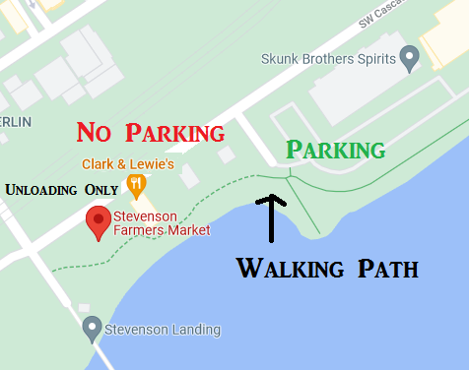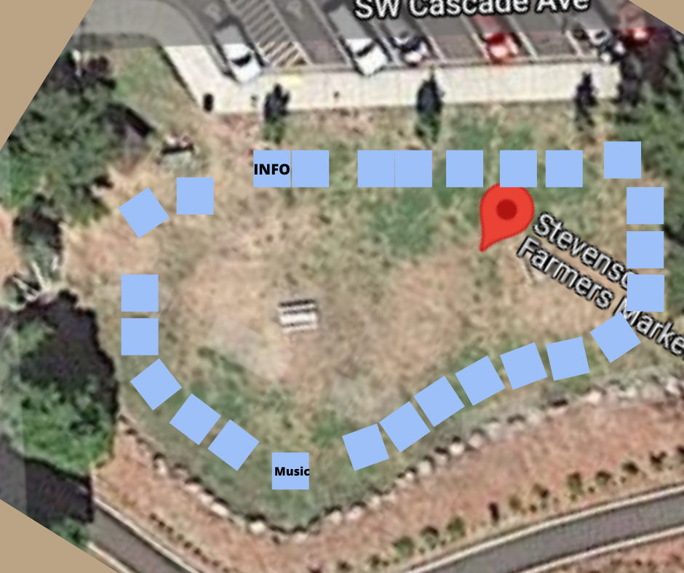

Memorandum of Understanding – 2021

The Stevenson Farmers’ Market is a voluntary association of independent producers which sells vegetables, fruits, herbs, flowers, jams, jellies, honey and certain other related items to the public on a site that is available with the permission of the site owner.

The Market is a “producer only” market. Resale of farm or garden products is only permitted with prior approval by the Market managers. Commercial, imported, or second-hand items are not allowed. Franchises are not allowed.

Each participant is an independent business and is responsible for complying with all local, state, and federal laws and with other requirements related to their business and the products that they offer for sale at the Market. These laws and requirements include but are not limited to requirements related to taxes, food safety, and public safety.

Each seller is responsible for keeping clean both their space and the market area in general.

The market operates under the guidance of a manager or co-managers who are hired and paid or elected by participants at a meeting of the Market steering committee. The manager(s) may delegate manager responsibilities to other participants.

Because of the limited space available, the manager(s) will assign spaces to permanent participants and will decide if temporary vendors are allowed to sell at the Market.
The manager(s) or a representative may monitor ethical practices at the Market.

Participants agree to hold harmless the Stevenson Farmers Market, its agents, other participants, and the property owner from any claims made by any person or organization related to food quality, compliance with laws and regulations, public safety, public health, or any other matter.

Protection related to product liability is the sole responsibility of each participant.

Name:
Farm Name:
Address:
Phone: | Email:
Business Website:

Would you like to have a link to your website on the Stevenson Farmers Market website?
Will all products being sold originate at your facility or farm? If not, please list location of origin.
Please list all products you plan to sell at the market:

Please circle the dates you plan to attend the market: 6/11, 6/18, 6/25, 7/2, 7/9, 7/16, 7/23 ,

7/30, 8/6, 8/13(fair weekend), 8/20, 8/27, 9/3, 9/10, 9/17, 9/24, 10/1, 10/8
Our market will be matching WIC, SFMNP, and SNAP again this year.
For every Voucher received Vendors will be encouraged to double the amount of Produce a costumer will receive. At the end of the day the market will pay the vendor for Vouchers matched. We will match every $4 WIC and SFMNP voucher received. SNAP benefits are doubled at time of market dollar purchase.
To accept these government subsidies you must sign up as a Grower with the Department of Health before July 1
https://www.doh.wa.gov/YouandYourFamily/WIC/FarmersMarket/GrowersMarketsandFarmStores

I will accept WIC & SFMNP vouchers Yes__No__

I (we) have read, understand, and agree to abide by the market guidelines and memorandum of understanding of the Stevenson Farmers’ Market.

___________________________________________ _____________________
Applicant Date

